**FRESH POND FESTIVAL**

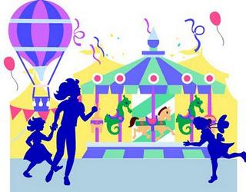

Join us for the ***Fun, Food and more!***

Saturday August 27,2016 and Sunday August 28, 2016

From 4 p.m. to 10 p.m.

*See You There!*